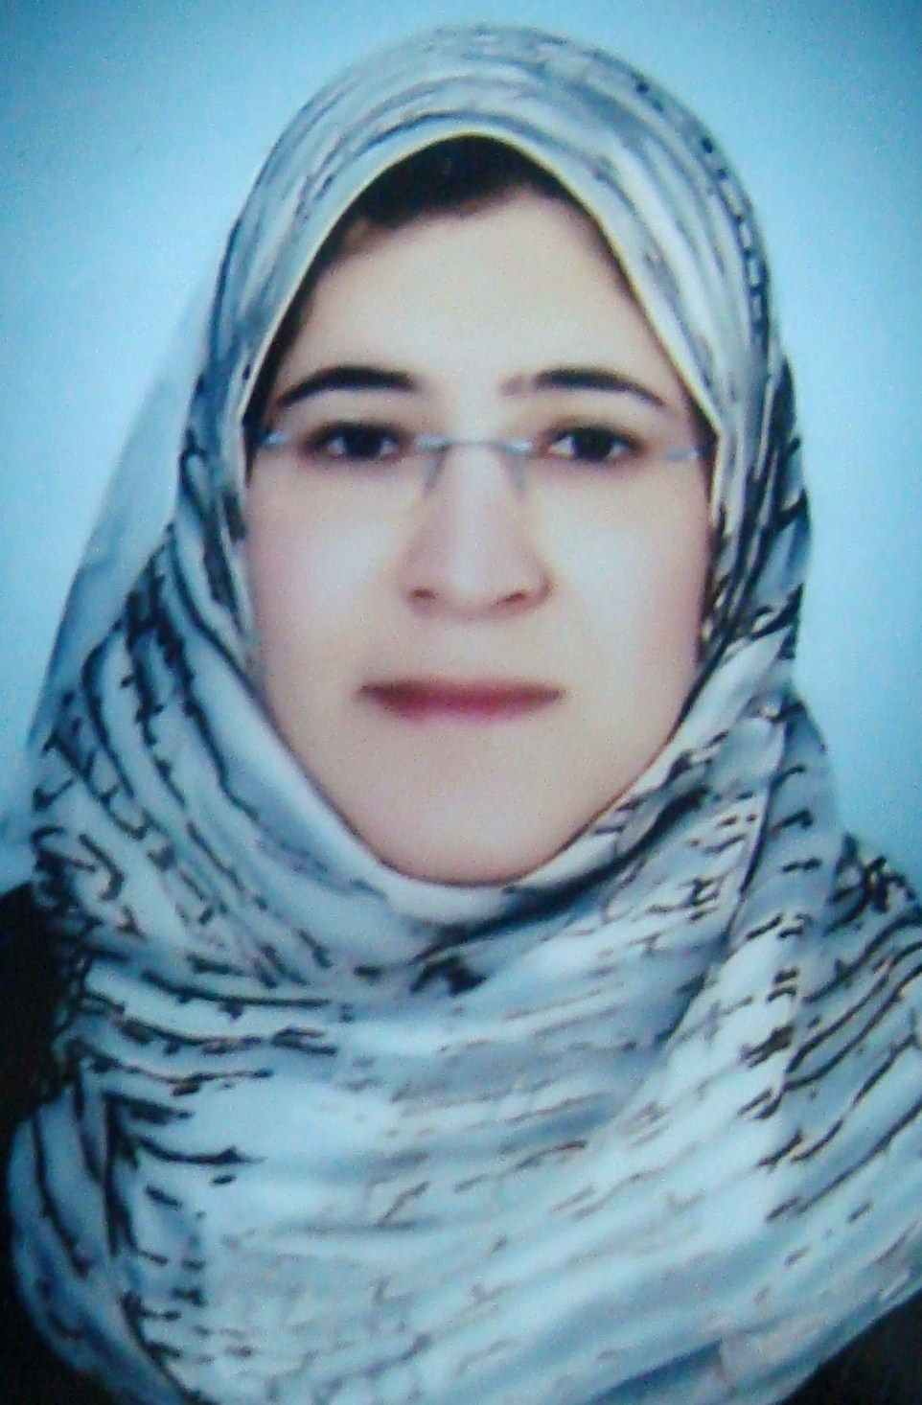
CURRICULUM VITAE

1. PERSONAL DATA:
Name: | Shimaa Gafer Mansour Hasan.
Sex: | Female.
Date of birth: | 3/5/1981
Nationality: | Egyptian.
Marital status: | Married.
Correspondence address: | Department of Clinical Pathology,South Egypt Cancer Institute ,Assiut University,Egypt.  Mobile: +20164824053.
E-Mail: | drshimaagaf@yahoo.com
Current home address: | 9 Goda El-Asady Street, Sherket Feryal, Assiut,Egypt.
Speciality: | Clinical Pathology.

2. QUALIFICATIONS:
2004 | Bachelors of Medicine and Surgery (MBBCH) “Excellant”.  Faculty of Medicine, Assiut University, Egypt.
2010 | Master Degree in Clinical Pathology (M.Sc.)  Faculty of Medicine, Assiut University, Egypt.

3. POSTS HELD:
From | To | Place of work | Post
1/3/2005 | 28/2/2006 | Assiut University Hospital | House Officer.
1/3/2006 | 31/5/2010 | South Egypt Cancer Institute | Resident doctor in Department of Clinical Pathology,
From 1/6/2010 till now | Assistant lecturer in Department of Clinical Pathology,  South Egypt Cancer Institute ,  Assiut University.

